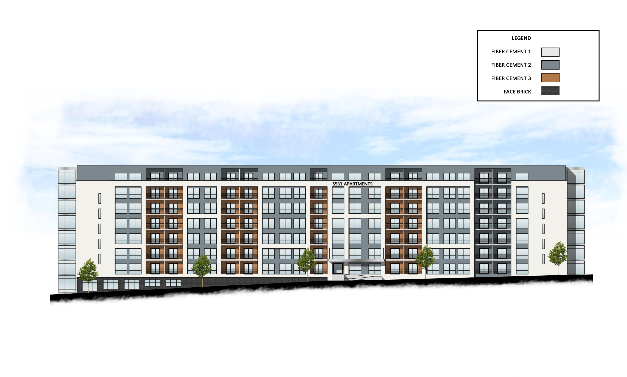
6531 W. Broad
Apartments
9.16.2021

